DBMS – Continuous Assessment 1

Praneesh R V

CB.SC.U4CYS23036

Scenario 1

Table 1

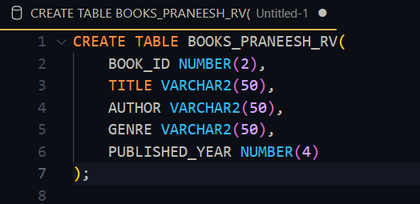

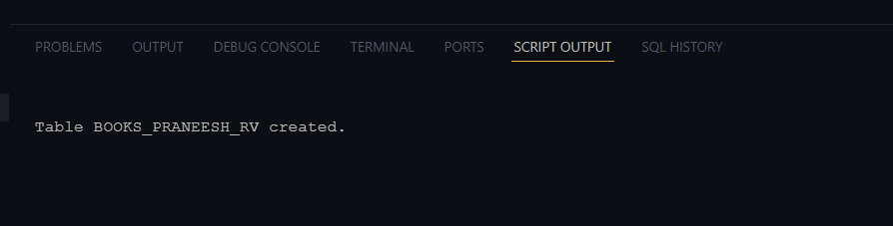

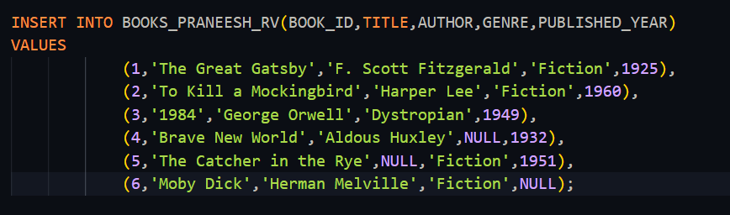

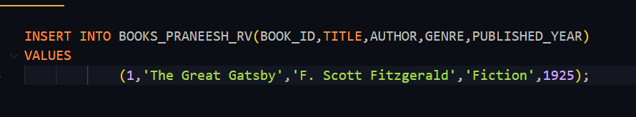



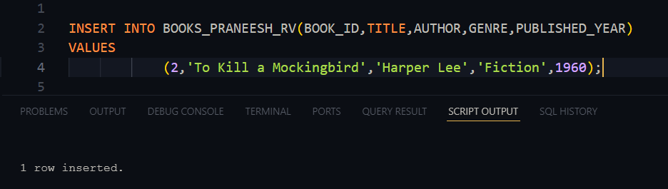

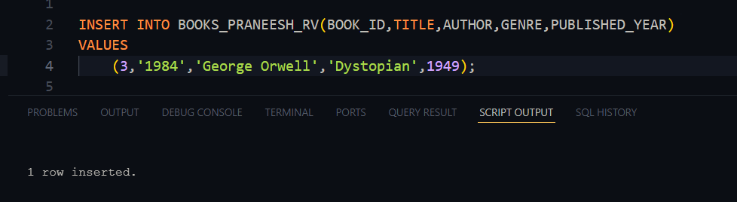

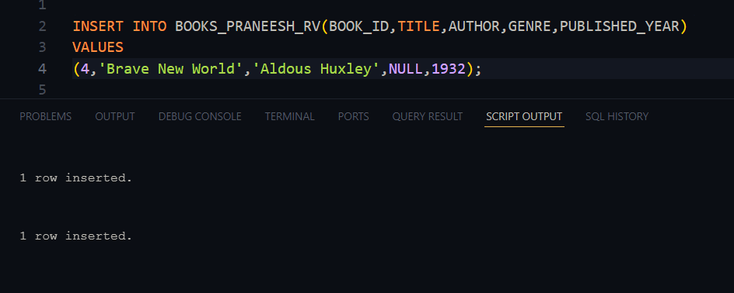

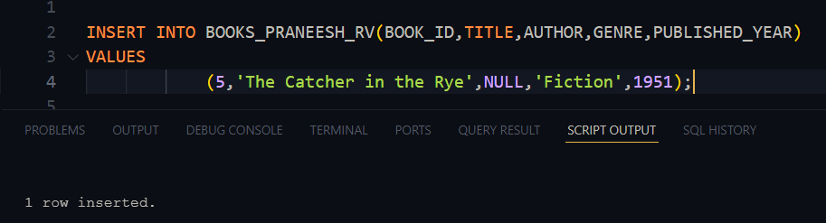

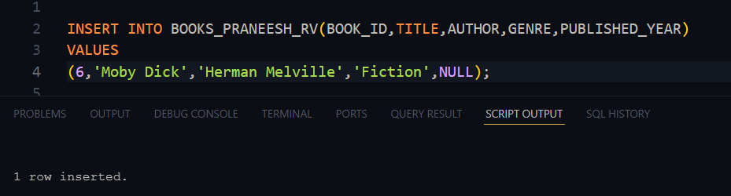

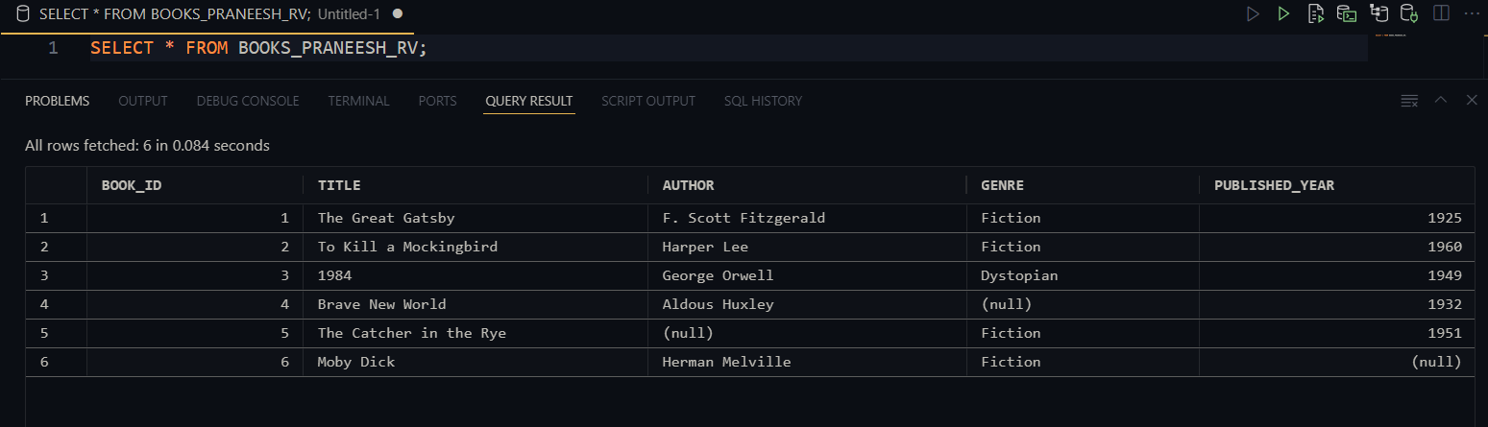

Table 2,

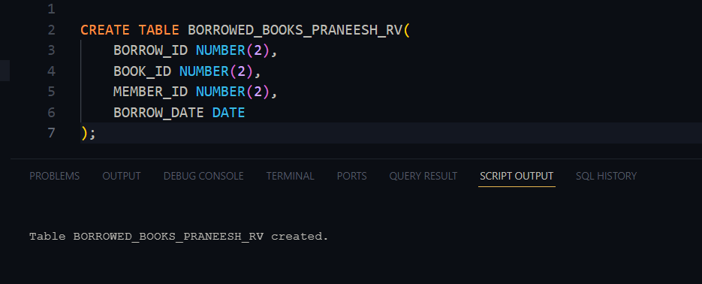

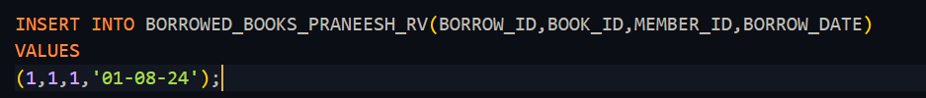

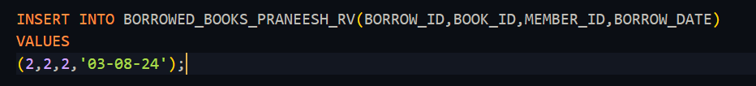

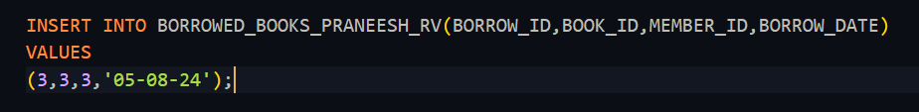

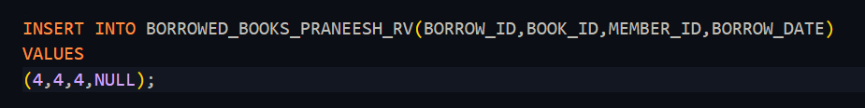

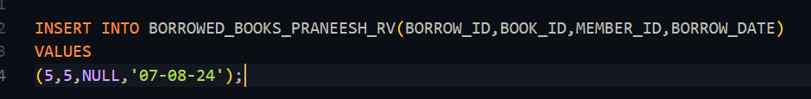

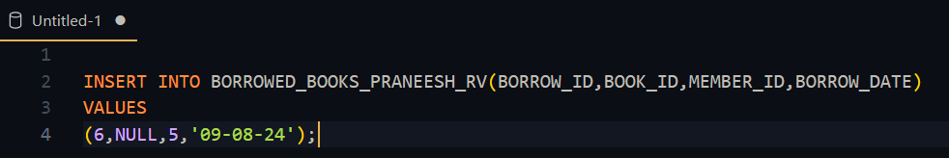



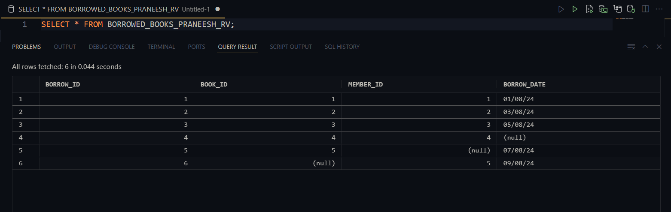

Table 3,

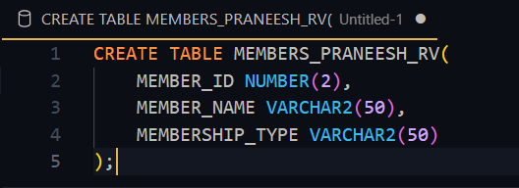

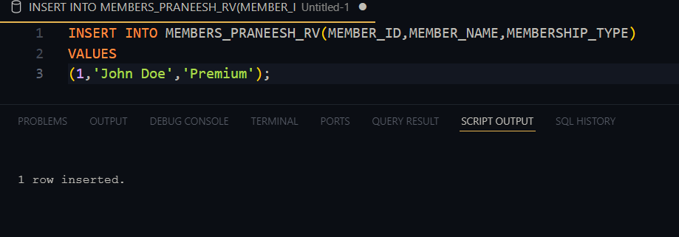

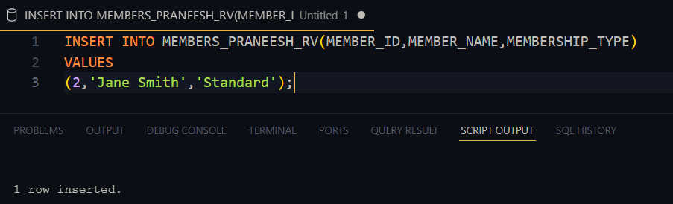

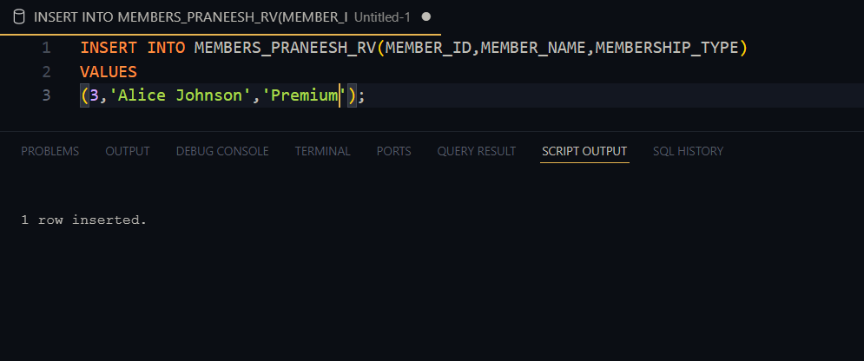

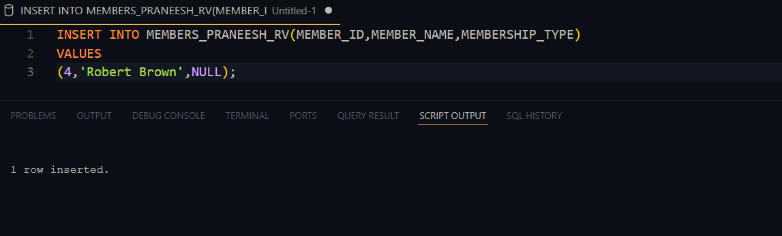

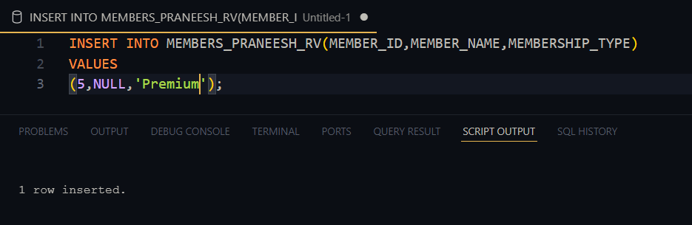

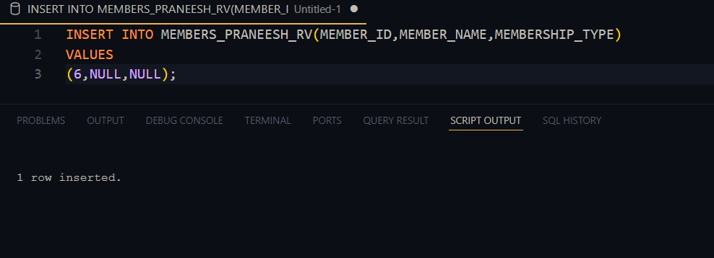

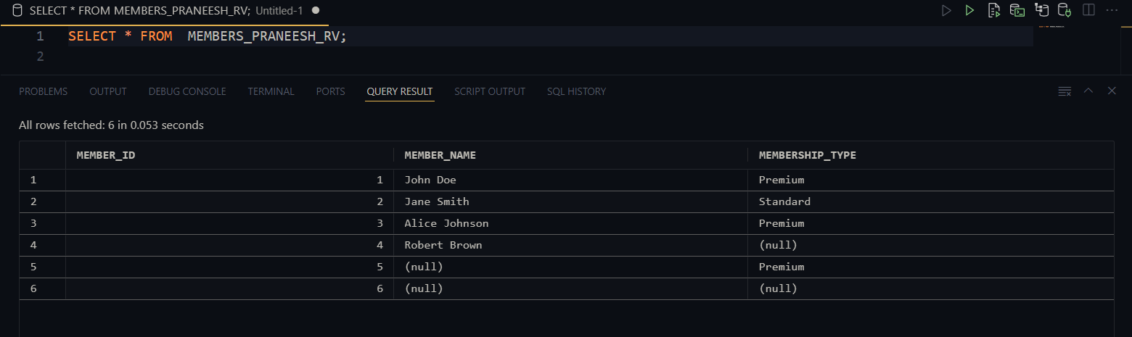

Questions:

Qn 1,Members with Premium membership  
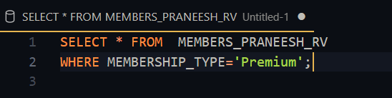



John Doe, Alice Johnson and member id 5 whose name is null

Qn 2,total number of books borrowed

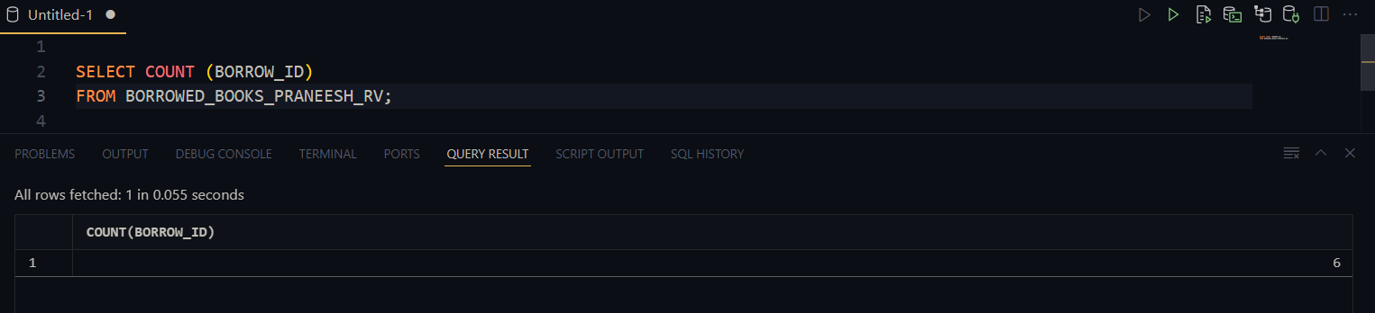

6

Qn 3,

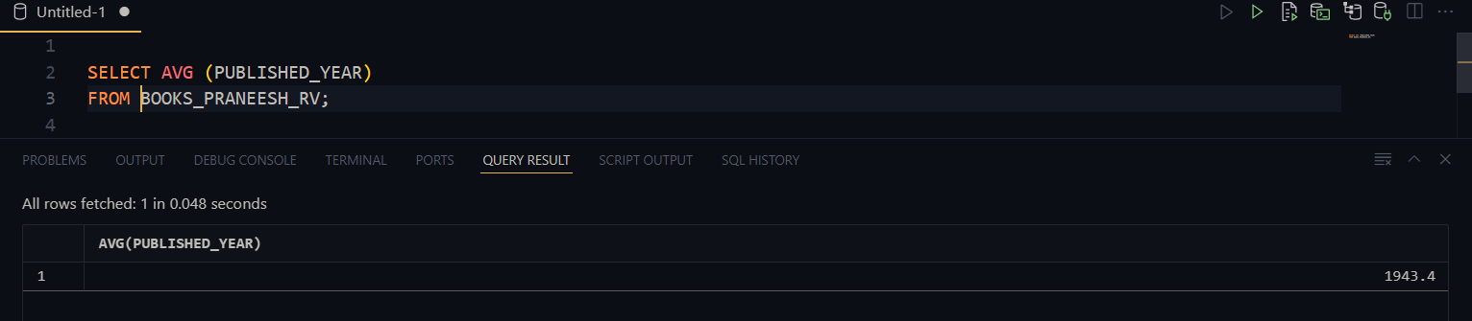

1943

Qn 4,

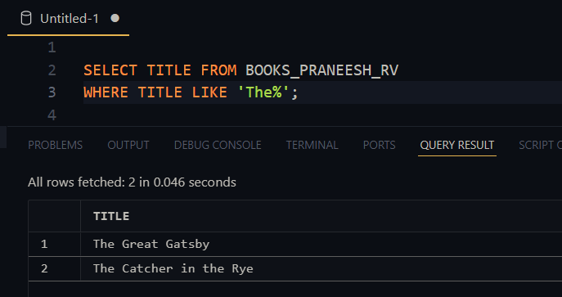

The Great Gatsby, The Catcher in the Rye

Qn 5,

Most Recent Borrow Date

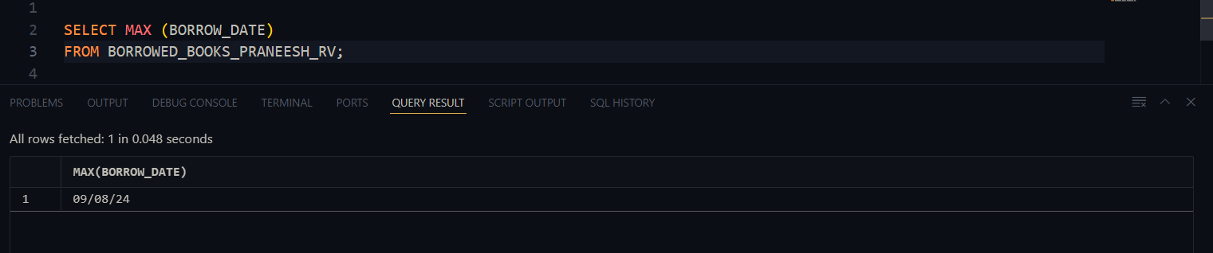

09-08-24

Joins

Qn 1,



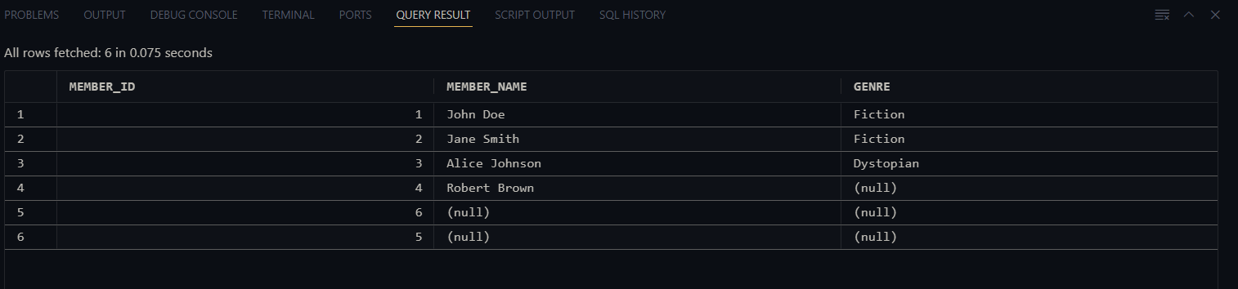

Scenario 2,

Table 1

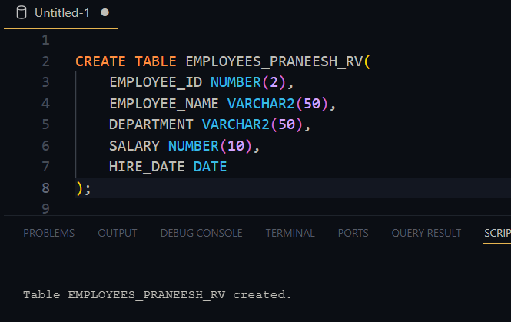

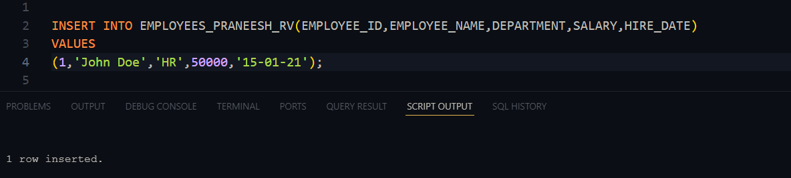

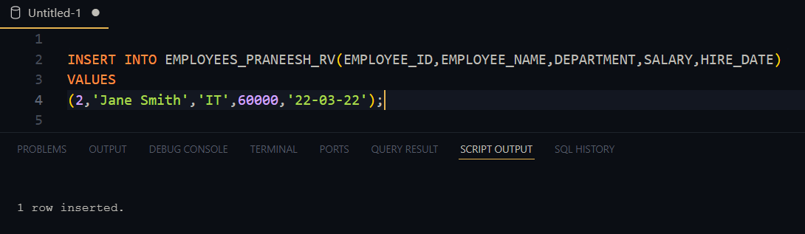

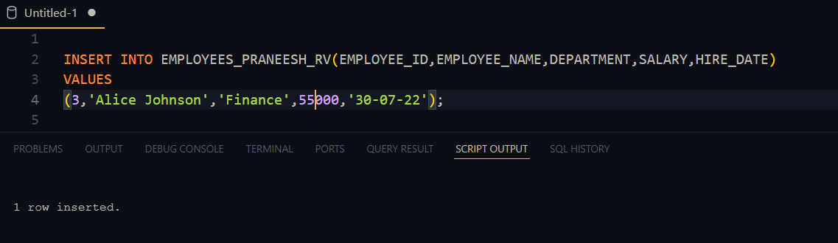

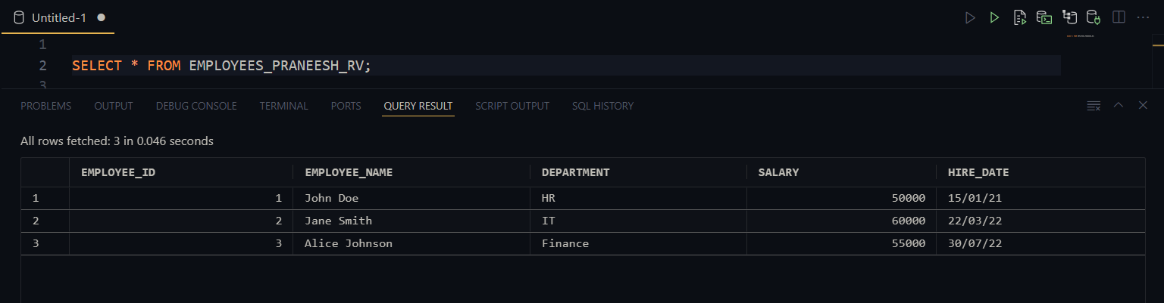

Table 2,

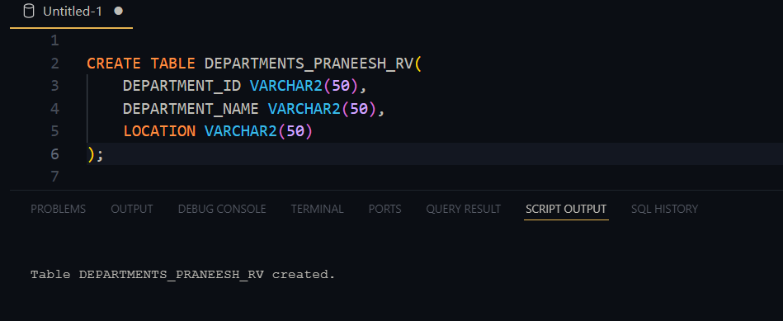

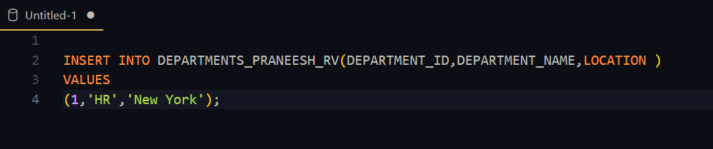

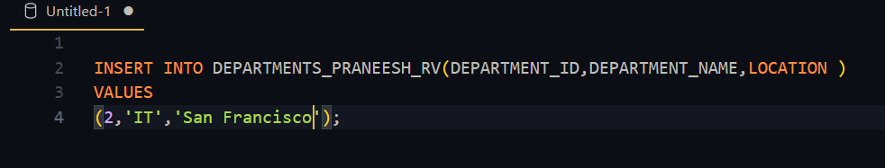

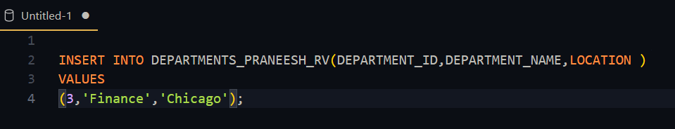

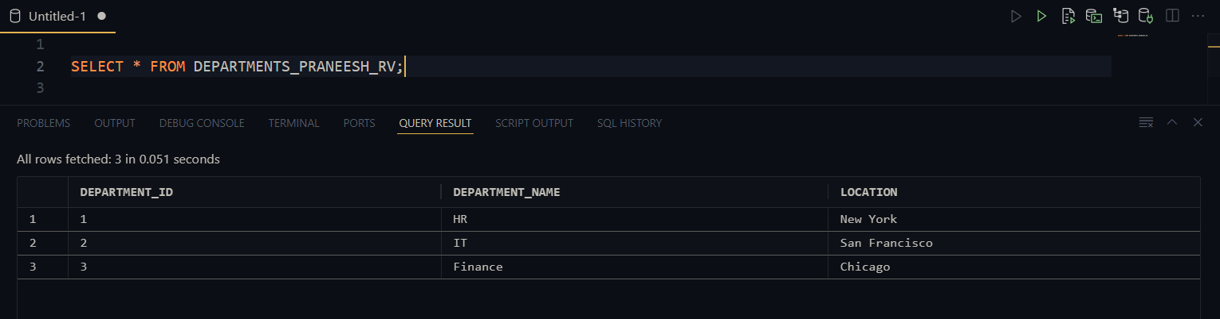

Table 3,

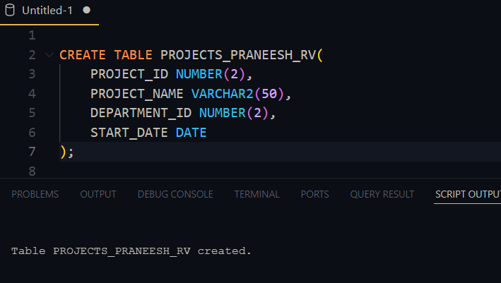

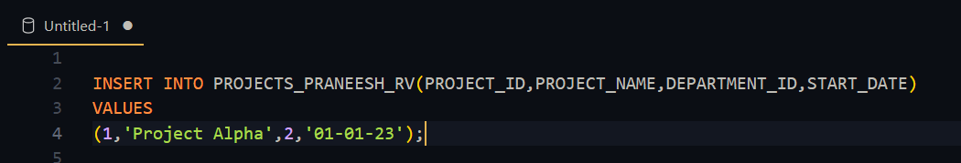

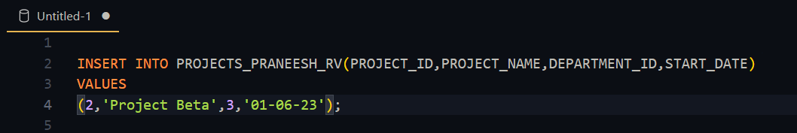

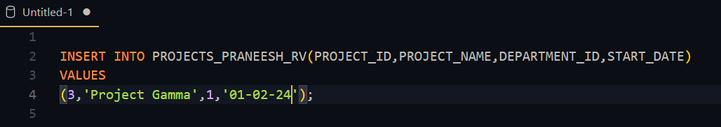

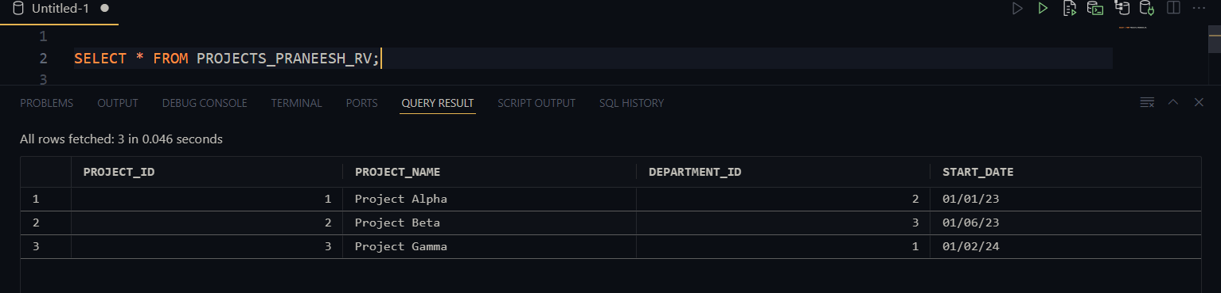

Questions

Qn1,

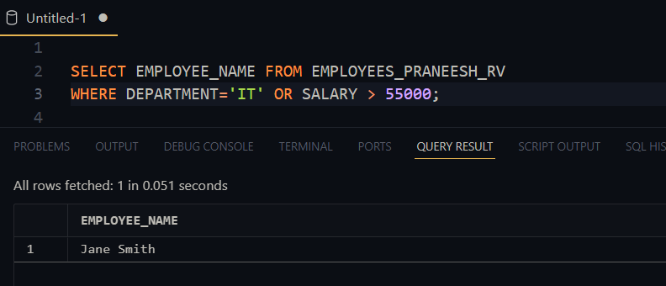

Jane smith

Qn2,

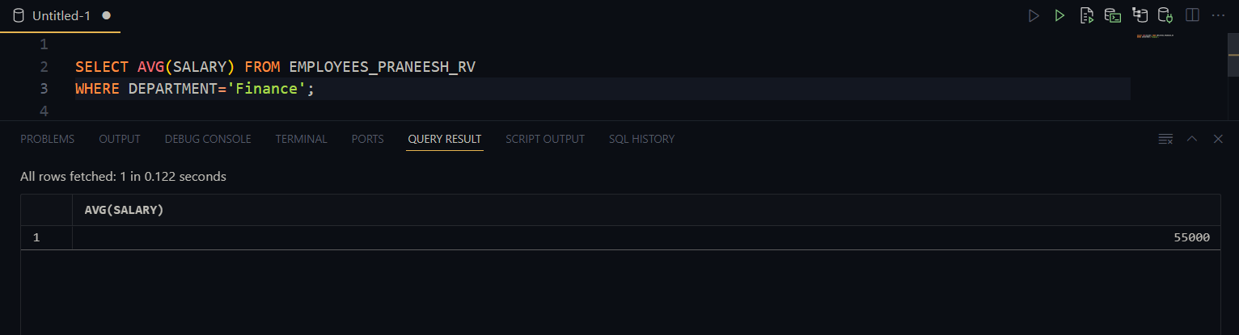

Average – 55000

Qn 3,

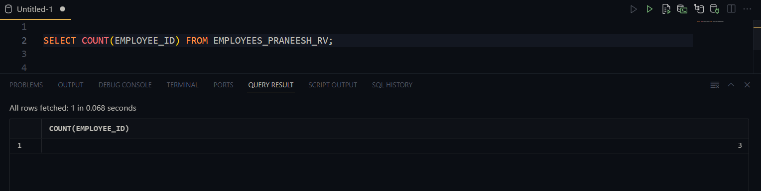

3 employees

Joins

Qn 1,

